|  |
| --- |
| **Paws**  **for**  **Applause** |
| Test Results |
| Elite Cars |
|  |
|  |
| **02/03/2017** |

Contents

|  |  |
| --- | --- |
|  | Page |
| Abstract | 2 |
| 1. Automated Tests – jUnit Output | 3 |
| 2. Automated Tests – Code Coverage Output | 4 |
| Appendix - References | 5 |

|  |
| --- |
|  |

Abstract

The Elite Cars system is designed for Elite Cars a luxury car rental company, founded by 3 car enthusiasts in 2010 . Specific intended users include the administrator and the customers.

This technical document contains a list of automated tests. Automated tests were conducted in using the jUnit package and EclEmma extension for code coverage in the Eclipse integrated development environment. Test details include automated test ID, date tested, test method name, description, status of test, code coverage, expected outcome, actual outcome and comments.

1. Automated Tests - jUnit Output

This section shows the results of the combined test output of all unit tests as output by jUnit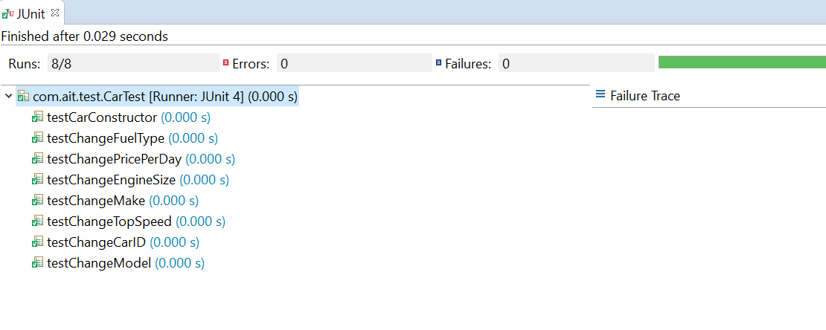

2. Automated Tests – Code Coverage Output

This section shows the code coverage percentage of the combined test output of all unit tests as created by the EclEmma extension.

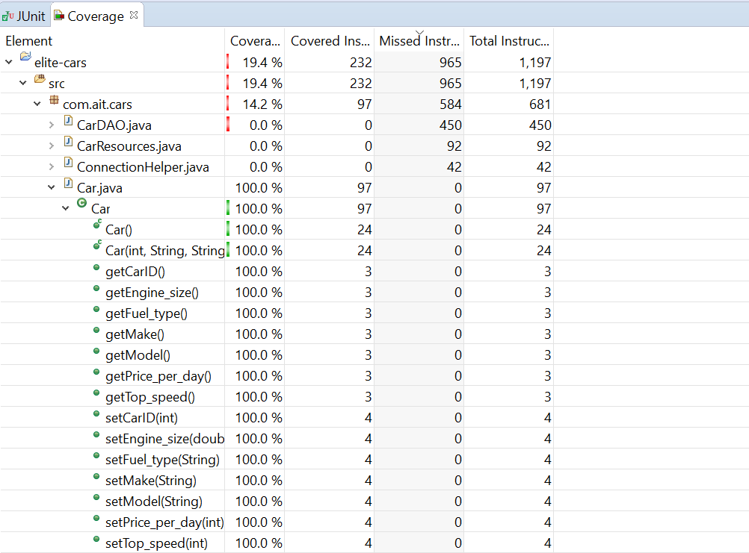

Appendix – References

* EclEmma, (2012), *EclEmma - Java Code Coverage for Eclipse – Overview*. Available at:

<http://www.eclemma.org/>

* jUnit, (2016), *jUnit – About*. Available at : <http://junit.org/junit4/> .